Prediction of Solar Power using LSTM and Artificial Neural Networks

Nail Tosun
Electrical and Electronics Engineering
Middle East Technical University
Ankara,Turkey
nailtosun@metu.edu.tr
Murat Göl
Electrical and Electronics Engineering
Middle East Technical University
Ankara, Turkey
nailtosun@metu.edu.tr
line 1: 3rd Given Name Surname
line 2: dept. name of organization
(of Affiliation)
line 3: name of organization
(of Affiliation)
line 4: City, Country
line 5: email address

Abstract— In this paper
Keywords— Solar Forecasting, Long-short Term Memory, Artificial Neural Networks

Introduction
The power grids always should be ensured an optimal balance between production and consumption of electricity. There are several methods for forecasting demand of the electricity. However, increasing the ratio of production by renewables raises problems on production side due to their high dependence on meteorological variance. From 2016 to 2017 solar power generation capacity increased by %31 to 389 572 MW. [1] With that trajectory, forecasting for solar power supply is crucial for power grids optimal operation. There are different solar forecasting methodologies with different time horizons in the literature like statistical learning methods, satellite imagery, sky imagers, Numerical weather prediction with output statistics and climatology [2]. In this paper our main focus is the minimal cost solution for forecasting. Therefore we used statistical learning methods like ANN, RNN and LSTM’s. For neural network input features, we used an API for inexpensive meteorological data and a solarlogger.
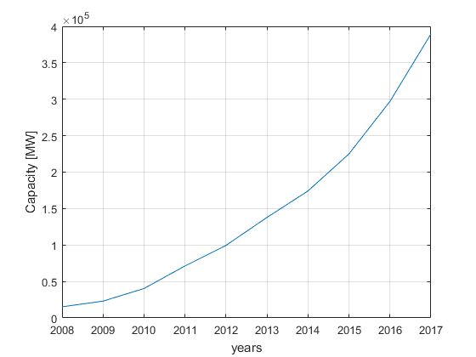

Datasets

Historic Power Generation Data
The data we working with is 50 kW roof-top photovoltaic panels which power generation logged by a datalogger with 5 minute resolution. The error occurs due to measurement device (solar-logger) is eliminated by DKT which proposed at [4].

Meteorological Data
The meteorological data obtained by an API which cost less than 10$ for three months with 5 minute resolution. The data consist of cloud cover, temperature, dew point and pressure data. The significance of dew point data is giving information about foggy weather to learning algoritm.

LSTM
Before you begin to format your paper, first write and save the content as a separate text file. Complete all content and organizational editing before formatting. Please note sections A-D below for more information on proofreading, spelling and grammar.
Keep your text and graphic files separate until after the text has been formatted and styled. Do not use hard tabs, and limit use of hard returns to only one return at the end of a paragraph. Do not add any kind of pagination anywhere in the paper. Do not number text heads-the template will do that for you.

Adam
Define abbreviations and acronyms the first time they are used in the text, even after they have been defined in the abstract. Abbreviations such as IEEE, SI, MKS, CGS, sc, dc, and rms do not have to be defined. Do not use abbreviations in the title or heads unless they are unavoidable.

Adagrad
- Use either SI (MKS) or CGS as primary units. (SI units are encouraged.) English units may be used as secondary units (in parentheses). An exception would be the use of English units as identifiers in trade, such as “3.5-inch disk drive”.
- Avoid combining SI and CGS units, such as current in amperes and magnetic field in oersteds. This often leads to confusion because equations do not balance dimensionally. If you must use mixed units, clearly state the units for each quantity that you use in an equation.
- Do not mix complete spellings and abbreviations of units: “Wb/m2” or “webers per square meter”, not “webers/m2”. Spell out units when they appear in text: “. . . a few henries”, not “. . . a few H”.
- Use a zero before decimal points: “0.25”, not “.25”. Use “cm3”, not “cc”. (bullet list)
Identify applicable funding agency here. If none, delete this text box.

SGD
The equations are an exception to the prescribed specifications of this template. You will need to determine whether or not your equation should be typed using either the Times New Roman or the Symbol font (please no other font). To create multileveled equations, it may be necessary to treat the equation as a graphic and insert it into the text after your paper is styled.
Number equations consecutively. Equation numbers, within parentheses, are to position flush right, as in (1), using a right tab stop. To make your equations more compact, you may use the solidus ( / ), the exp function, or appropriate exponents. Italicize Roman symbols for quantities and variables, but not Greek symbols. Use a long dash rather than a hyphen for a minus sign. Punctuate equations with commas or periods when they are part of a sentence, as in:
a  b    
Note that the equation is centered using a center tab stop. Be sure that the symbols in your equation have been defined before or immediately following the equation. Use “(1)”, not “Eq. (1)” or “equation (1)”, except at the beginning of a sentence: “Equation (1) is . . .”

RmsPROP
- The word “data” is plural, not singular.
- The subscript for the permeability of vacuum μ₀, and other common scientific constants, is zero with subscript formatting, not a lowercase letter “o”.
- In American English, commas, semicolons, periods, question and exclamation marks are located within quotation marks only when a complete thought or name is cited, such as a title or full quotation. When quotation marks are used, instead of a bold or italic typeface, to highlight a word or phrase, punctuation should appear outside of the quotation marks. A parenthetical phrase or statement at the end of a sentence is punctuated outside of the closing parenthesis (like this). (A parenthetical sentence is punctuated within the parentheses.)
- A graph within a graph is an “inset”, not an “insert”. The word alternatively is preferred to the word “alternately” (unless you really mean something that alternates).
- Do not use the word “essentially” to mean “approximately” or “effectively”.
- In your paper title, if the words “that uses” can accurately replace the word “using”, capitalize the “u”; if not, keep using lower-cased.
- Be aware of the different meanings of the homophones “affect” and “effect”, “complement” and “compliment”, “discreet” and “discrete”, “principal” and “principle”.
- Do not confuse “imply” and “infer”.
- The prefix “non” is not a word; it should be joined to the word it modifies, usually without a hyphen.
- There is no period after the “et” in the Latin abbreviation “et al.”.
- The abbreviation “i.e.” means “that is”, and the abbreviation “e.g.” means “for example”.
An excellent style manual for science writers is [7].

Results
After the text edit has been completed, the paper is ready for the template. Duplicate the template file by using the Save As command, and use the naming convention prescribed by your conference for the name of your paper. In this newly created file, highlight all of the contents and import your prepared text file. You are now ready to style your paper; use the scroll down window on the left of the MS Word Formatting toolbar.

LSTM with 5 min time series
In this work we used 30353 data points with 5 minutes resolution with correspond approx. 105 days of solar power generation data. Data are collected April to June which have high variance on cloud cover.

Optimizing the batch size: Add author names horizontally, moving gen o a third row if needed for more than 8 authors.

Optimizer comparison: To change the default, adjust the template as follows.

Selection: Highlight all author and affiliation lines.

Change number of columns: Select the Columns icon from the MS Word Standard toolbar and then select the correct number of columns from the selection palette.

Deletion: Delete the author and affiliation lines for the extra authors.

Optimizer Performances
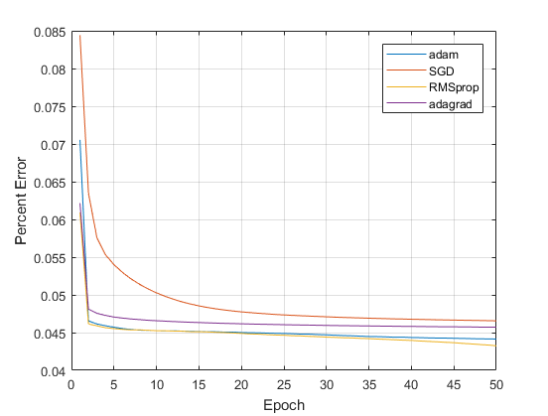Component heads identify the different components of your paper and are not topically subordinate to each other. Examples include Acknowledgments and References and, for these, the correct style to use is “Heading 5”. Use “figure caption” for your Figure captions, and “table head” for your table title. Run-in heads, such as “Abstract”, will require you to apply a style (in this case, italic) in addition to the style provided by the drop down menu to differentiate the head from the 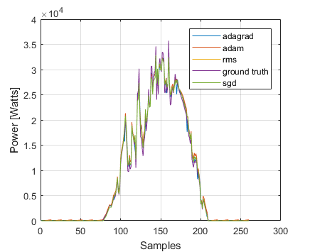

Figures and Tables

Positioning Figures and Tables: Place figures and tables at the top and bottom of columns. Avoid placing them in the middle of columns. Large figures and tables may span across both columns. Figure captions should be below the figures; table heads should appear above the tables. Insert figures and tables after they are cited in the text. Use the abbreviation “Fig. 1”, even at the beginning of a sentence.
- Table Type Styles
Table Head | LSTM performances over days data
Table Head | Optimizer | Batch-size | Percent -Error
copy | Adam | 14 | %10.34
 | RMSprop | 14 | %10.15
 | SGD | 14 | %11.18
 | Adagrad | 14 | %10.39
 | RMSprop | 7 | %9.64
- Sample of a Table footnote. (Table footnote)
- Example of a figure caption. (figure caption)
Figure Labels: Use 8 point Times New Roman for Figure labels. Use words rather than symbols or abbreviations when writing Figure axis labels to avoid confusing the reader. As an example, write the quantity “Magnetization”, or “Magnetization, M”, not just “M”. If including units in the label, present them within parentheses. Do not label axes only with units. In the example, write “Magnetization (A/m)” or “Magnetization {A[m(1)]}”, not just “A/m”. Do not label axes with a ratio of quantities and units. For example, write “Temperature (K)”, not “Temperature/K”.

Acknowledgment (Heading 5)
The preferred spelling of the word “acknowledgment” in America is without an “e” after the “g”. Avoid the stilted expression “one of us (R. B. G.) thanks ...”. Instead, try “R. B. G. thanks...”. Put sponsor acknowledgments in the unnumbered footnote on the first page.

References
The template will number citations consecutively within brackets [1]. The sentence punctuation follows the bracket [2]. Refer simply to the reference number, as in [3]—do not use “Ref. [3]” or “reference [3]” except at the beginning of a sentence: “Reference [3] was the first ...”
Number footnotes separately in superscripts. Place the actual footnote at the bottom of the column in which it was cited. Do not put footnotes in the abstract or reference list. Use letters for table footnotes.
Unless there are six authors or more give all authors’ names; do not use “et al.”. Papers that have not been published, even if they have been submitted for publication, should be cited as “unpublished” [4]. Papers that have been accepted for publication should be cited as “in press” [5]. Capitalize only the first word in a paper title, except for proper nouns and element symbols.
For papers published in translation journals, please give the English citation first, followed by the original foreign-language citation [6].

- G. Eason, B. Noble, and I. N. Sneddon, “On certain integrals of Lipschitz-Hankel type involving products of Bessel functions,” Phil. Trans. Roy. Soc. London, vol. A247, pp. 529–551, April 1955. (references)
- J. Clerk Maxwell, A Treatise on Electricity and Magnetism, 3rd ed., vol. 2. Oxford: Clarendon, 1892, pp.68–73.
- I. S. Jacobs and C. P. Bean, “Fine particles, thin films and exchange anisotropy,” in Magnetism, vol. III, G. T. Rado and H. Suhl, Eds. New York: Academic, 1963, pp. 271–350.
- K. Elissa, “Title of paper if known,” unpublished.
- R. Nicole, “Title of paper with only first word capitalized,” J. Name Stand. Abbrev., in press.
- Y. Yorozu, M. Hirano, K. Oka, and Y. Tagawa, “Electron spectroscopy studies on magneto-optical media and plastic substrate interface,” IEEE Transl. J. Magn. Japan, vol. 2, pp. 740–741, August 1987 [Digests 9th Annual Conf. Magnetics Japan, p. 301, 1982].
- M. Young, The Technical Writer’s Handbook. Mill Valley, CA: University Science, 1989.

IEEE conference templates contain guidance text for composing and formatting conference papers. Please ensure that all template text is removed from your conference paper prior to submission to the conference. Failure to remove template text from your paper may result in your paper not being published.

We suggest that you use a text box to insert a graphic (which is ideally a 300 dpi TIFF or EPS file, with all fonts embedded) because, in an MSW document, this method is somewhat more stable than directly inserting a picture.
To have non-visible rules on your frame, use the MSWord “Format” pull-down menu, select Text Box > Colors and Lines to choose No Fill and No Line.

